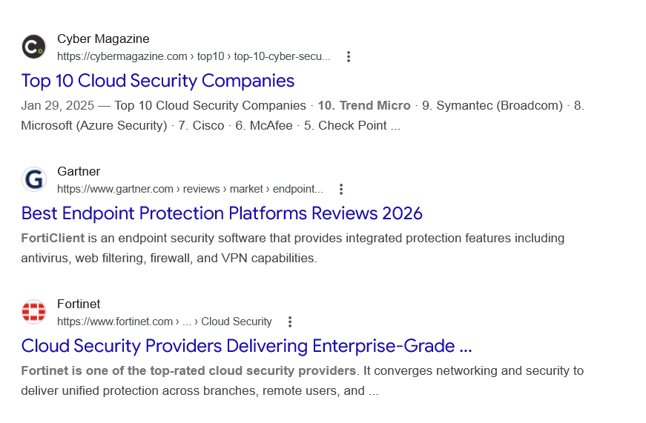
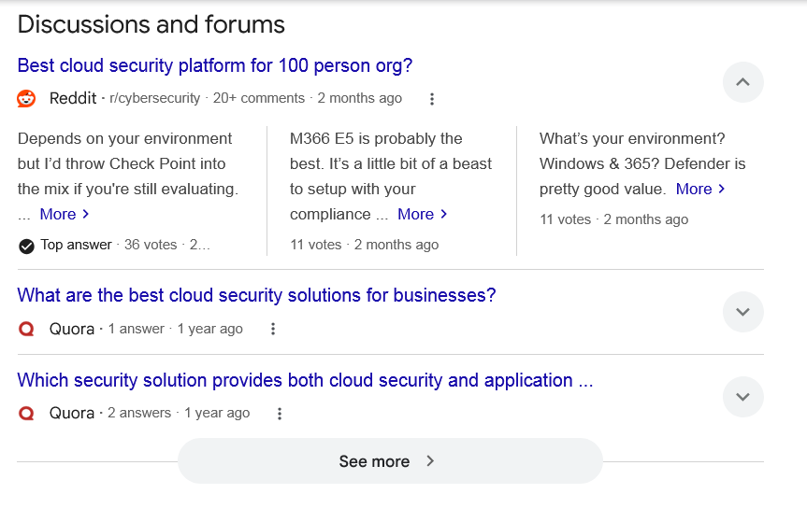
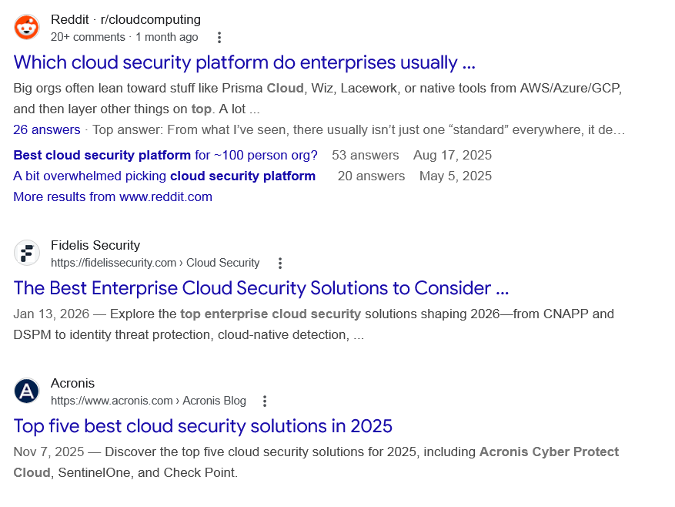
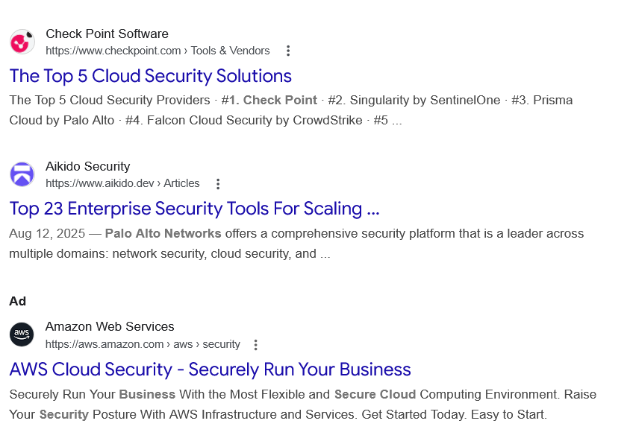
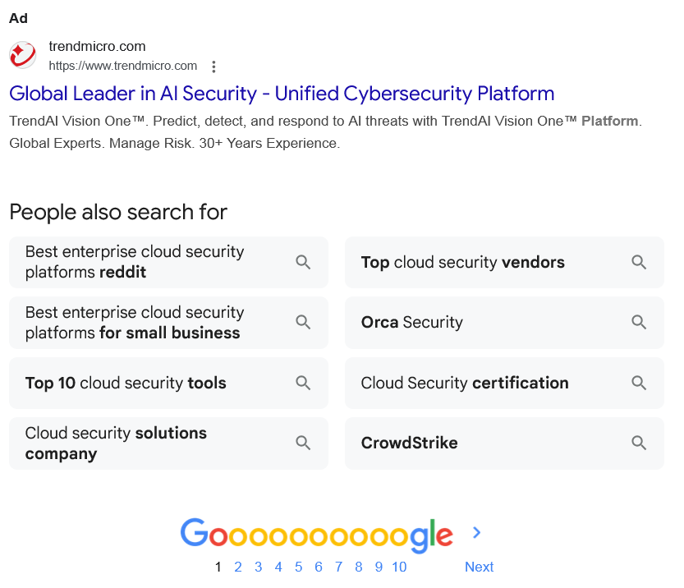

Web results

Top 10 Cloud Security Companies

Cyber Magazine
https://cybermagazine.com › top10 › top-10-cyber-secu...

Cyber Magazine
https://cybermagazine.com › top10 › top-10-cyber-secu...
Jan 29, 2025 — Top 10 Cloud Security Companies · 10. Trend Micro · 9. Symantec (Broadcom) · 8. Microsoft (Azure Security) · 7. Cisco · 6. McAfee · 5. Check Point ...

Best Endpoint Protection Platforms Reviews 2026

Gartner
https://www.gartner.com › reviews › market › endpoint...

Gartner
https://www.gartner.com › reviews › market › endpoint...
FortiClient is an endpoint security software that provides integrated protection features including antivirus, web filtering, firewall, and VPN capabilities.

Cloud Security Providers Delivering Enterprise-Grade ...

Fortinet
https://www.fortinet.com › ... › Cloud Security

Fortinet
https://www.fortinet.com › ... › Cloud Security
Fortinet is one of the top-rated cloud security providers. It converges networking and security to deliver unified protection across branches, remote users, and ...
Discussions and forums

Best cloud security platform for 100 person org?
Reddit ·
r/cybersecurity
· 20+ comments
· 2 months ago

Best cloud security platform for 100 person org?
Reddit ·
r/cybersecurity
· 20+ comments
· 2 months ago
Depends on your environment but I’d throw Check Point into the mix if you're still evaluating. ... More
Top answer · 36 votes · 2 months ago
M366 E5 is probably the best. It’s a little bit of a beast to setup with your compliance ... More
11 votes · 2 months ago
What’s your environment? Windows & 365? Defender is pretty good value. More
11 votes · 2 months ago

What are the best cloud security solutions for businesses?
Quora ·
1 answer
· 1 year ago

What are the best cloud security solutions for businesses?
Quora ·
1 answer
· 1 year ago
Some of the top cloud security solutions for businesses include: CrowdStrike, Palo Alto Networks (Prisma Cloud), Fortinet, ... More

Which security solution provides both cloud security and application ...
Quora ·
2 answers
· 1 year ago

Which security solution provides both cloud security and application ...
Quora ·
2 answers
· 1 year ago
None that I can recall and I spend much of my work life investigating such technologies. If I did wander across such a solution I would immediately discard ... More
Top answer · 2 votes · a year ago

See more

Web results

Which cloud security platform do enterprises usually ...

Reddit · r/cloudcomputing
20+ comments · 1 month ago

Reddit · r/cloudcomputing
20+ comments · 1 month ago
Big orgs often lean toward stuff like Prisma Cloud, Wiz, Lacework, or native tools from AWS/Azure/GCP, and then layer other things on top. A lot ...
26 answers · Top answer: From what I’ve seen, there usually isn’t just one “standard” everywhere, it depends ...
Best cloud security platform for ~100 person org?
53 answers
Aug 17, 2025
A bit overwhelmed picking cloud security platform
20 answers
May 5, 2025
More results from www.reddit.com

The Best Enterprise Cloud Security Solutions to Consider ...

Fidelis Security
https://fidelissecurity.com › Cloud Security

Fidelis Security
https://fidelissecurity.com › Cloud Security
Jan 13, 2026 — Explore the top enterprise cloud security solutions shaping 2026—from CNAPP and DSPM to identity threat protection, cloud-native detection, ...

Top five best cloud security solutions in 2025

Acronis
https://www.acronis.com › Acronis Blog

Acronis
https://www.acronis.com › Acronis Blog
Nov 7, 2025 — Discover the top five cloud security solutions for 2025, including Acronis Cyber Protect Cloud, SentinelOne, and Check Point.

The Top 5 Cloud Security Solutions

Check Point Software
https://www.checkpoint.com › Tools & Vendors

Check Point Software
https://www.checkpoint.com › Tools & Vendors
The Top 5 Cloud Security Providers · #1. Check Point · #2. Singularity by SentinelOne · #3. Prisma Cloud by Palo Alto · #4. Falcon Cloud Security by CrowdStrike · #5 ...

Top 23 Enterprise Security Tools For Scaling ...

Aikido Security
https://www.aikido.dev › Articles

Aikido Security
https://www.aikido.dev › Articles
Aug 12, 2025 — Palo Alto Networks offers a comprehensive security platform that is a leader across multiple domains: network security, cloud security, and ...
Ad

AWS Cloud Security - Securely Run Your Business

Amazon Web Services
https://aws.amazon.com › aws › security

Amazon Web Services
https://aws.amazon.com › aws › security

My Ad Centre
Securely Run Your Business With the Most Flexible and Secure Cloud Computing Environment. Raise Your Security Posture With AWS Infrastructure and Services. Get Started Today. Easy to Start.
Ad

Global Leader in AI Security - Unified Cybersecurity Platform

trendmicro.com
https://www.trendmicro.com

trendmicro.com
https://www.trendmicro.com

My Ad Centre
TrendAI Vision One™. Predict, detect, and respond to AI threats with TrendAI Vision One™ Platform. Global Experts. Manage Risk. 30+ Years Experience.
People also search for

Best enterprise cloud security platforms reddit

Best enterprise cloud security platforms for small business

Top 10 cloud security tools

Cloud security solutions company

Top cloud security vendors

Orca Security

Cloud Security certification

CrowdStrike

Page navigation
 | 1 | 2 | 3 | 4 | 5 | 6 | 7 | 8 | 9 | 10 | Next

